3 GEOLOGICAL (GEODYNAMIC) PROCESSES

Practical work of geologist takes place within the upper part of a hard shell (lithosphere) - the Earth's crust that is in constant interaction with the outer and inner shells having a different composition and other physical properties than the crust. As a result of these interactions geological (or geodynamic) processes occur, which are divided into two groups: endogenous and exogenous.
Exogenous geological processes develop from the interaction of the Earth's crust with the atmosphere, hydrosphere and biosphere. Exogenous agents, causing any phenomenon in nature are: wind, rivers, glaciers, underground water, seas, oceans, lakes, swamps.
Endogenous geological processes are linked to interaction of earth crust with internal shells and development of matter in deep bowels of planet, i.е. they are caused mainly by internal forces of the Earth. They are due to the energy released during the development of the substance of the Earth, the force of gravity and the forces generated by the Earth's rotation. They are: vibrational and tectonic movements of the earth's crust, plicative and disjunctive deformation, earthquake, magmatism and metamorphism.
Endogenous and exogenous geological processes are strictly interrelated and interdependent. External agents constantly destroy what is created by endogenous processes, and at the same time create a new substance that is stable in the new environment. A substance formed on the surface becomes unstable in the bowels and, if it adjudge there, it will be converted. This clearly shows the dialectical law of the unity and struggle of opposites. Thereby continuous redistribution of matter and the formation of its new forms and species that cause flow of the river, moving mountains and the sea, supporting the life due to revenues from the depths of all new materials occures.
Magmatism of all geological processes is considered primary, as the Earth until the modern state went through a common magmatic stage.
EARTH CRUST, ITS TRUCTURE, TYPES AND COMPOSITION

Earth crust is considered separately because this geosphere is the main object of geology and environment of industrial human activity.
Structure of the earth crust
The most important feature of the crustal structure is clearly marked heterogeneity, manifested in both the vertical and horizontal direction.
Vertical heterogeneity. Three shales (or layers) are given out by seismical researches in structure of earth crust, composed of rocks of different composition, characteristics and origin: stratisphere (sedimentary shell), granite and basalt (fig. 3.1).
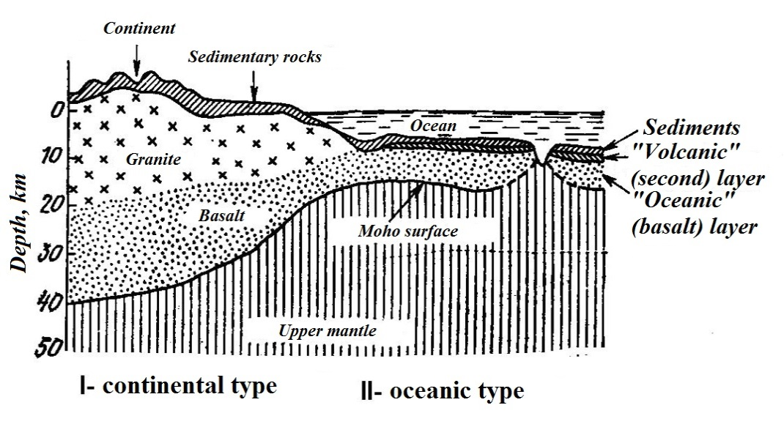
Fig. 3.1. Structure and types of earth crust

Stratisphere (Lat. "Stratum" - a layer) is composed by sedimentary and volcanogenic-sedimentary rocks, (%): clays and clay shales (42), sandy (20), volcanogenic (19) and carbonate (19) rocks. Layer covers almost the whole surface of the Earth and in deep depressions, for example, in the Caspian depression, it reaches the thickness of 23 km (on average in stratisphere – 3 km). It is characteristic for rocks of sedimentary cover: weak dislocation, relatively low density and small changes, corresponding to diagenetic. Volcanogenous rocks have limitted spread. Average density of rocks of the whole всего sedimentary cover is 2.5 g/сm³, limits of its changes 2.28–2.80 g/сm³. Speed of elastic waves’ spread (V_{p}) on sedimentary cover linked to the material composition of rocks, degree of compaction and vary from 1.8 to 5.0 km/s and more.
Granite shale, called because of the similarity of the properties of its constituent species to the properties of granites, is composed, (%): gneisses (37.6), granodiorites and diorites (19.9), granites (18.1), amphibolites (9.8), crystall shists (9.0), and also gabbro, marbles, syenites and etc. Rocks, composing granite layer, are very various by their material composition and degree of their dislocation. They are represented as unchanged, and metamorphic rocks. Depending on the structure and composition of the granite layer its density varies from 2.6 to 2.8 g/сm³, averaging 2,7 g/сm³.
Granite shell is separated from the sediment by sharp seismic boundary (velocity racing is 0.7 km/s). Stratal speed of elastic waves spread in granite layer varies from 5.0 to 6.5 km/s, with an average value of about 6 km/s. Thickness of granite layer in area of the CIS from 6 to 40 km. Perhaps, there is sometimes the complete absence of the granite layer in the section. Lower border of granite layer is seismical section (border) of Conrad.
Basalt shell - the third layer of the earth's crust - is made up of more severe crystalline rocks, whose properties are close to terrestrial basalts - magmatic rocks. The layer is composed by magmatic rocks of various metamorphic degrees. So-called eclogite layer with a higher density than the basalt layer rock lies in some places between the basalt layer and the mantle.
Average density of basalt layer rocks is 2.9 g/сm³, and density changes interval is 2.8–3.2 g/сm³. The speed of seismic wave spread (V_{p}) from 6 to 7.5 km/s. Herewith features of waves spread are linked to character of distribution of petrographically heterogeneous complexes in vertical section of basalt layer.
Average thickness of basalt layer within continental part of the CIS area is about 20 km. However in some areas (under the mountain ranges), it can reach 30–40 km. There are such areas (Caspian syneclise and etc.), where the thickness of basalt layer decreases to 12–13 and even to 5–7 km.
Average thickess of earth crust is 33 km, and within Kazakhstan it is 35–45 km. In some parts of the world there are significant deviations from the average thickness. Thus, minimal thickness of earth crust (7–12 km) is characteristic for oceans, and maximal (70–80 km) – for mountainous regions of continents. Lower boundary of earth crust as it mirrors the surface of the Earth. It is lowered into the deep mantle under the continents, under the oceans comes close to the Earth's surface, subject to the principle of "isostasy”. Earth crust is separated from mantle by Mohorovicic boundary (section or discontinuity of Moho).
Horizontal heterogeneity. Areal heterogeneity of crustal structure is manifested, first of all, in its various buildings on the continents and within oceanic depressions. This fact was first established by seismic data by B. Gutenberg. Lots of crust, placed the type of geological structure are called structural elements.
From the point of view of spatial development oceans and continents are structures I (planetary) order, differ greatly by geological structure and development character. Within the structural elements of I order II-order structures are identified on the specifics of the geological structure and development: on continents – platform and geosynclinal (mountain-fold) areas, on oceanic crust – platforms and mid-ocean ridges. In turn, called structure of the II order can be divided by structural features into smaller structural units (higher-order): global (III order), regional (IV order) and local (V order).
Minimal thickness of the crust is observed on platforms, maximal – on mountain-fold areas (geosynclinals).
Platforms are extensive tectonically stable region. They are characterized by: average and stable values of the earth crust’s thickness; horizontal or almost horizontal occurence of sedimentary rocks; flat relief. Platforms usually have two-tier structure and consist of older crystalline basement and the overlying sedimentary cover. There are Eastern European and Siberian platforms in the area of CIS.
Tectonic active zones (geosynclines) are linear extended tectonical motile zones. They are characterized by significant to 70–80 km thickness of earth crust and its sharp fluctuations; impaired fold-discontinuous occurrence of rocks; mountain relief. In geomorphological terms geosyncline is presented by linear mountain-folded structures. Such are, for example, Ural, Caucasus, Pamir and etc.
Types of earth crust
There are three types of earth crust by its composition and thickness: continental, oceanic, and transitional (fig. 3.1).
Crust of continental type consists of three layers: sedimentary, granite and basalt, total thickness of which reaches 70–80 km. thickness of sedimentary layer usually is not more than 10–15 km, speed of longitudinal seismical waves spreading in this layer rocks is 1.5–5 km/s. Granite layer occurs lower with thickness of 10–20 km, speed of longitudinal waves spreading in this layer rocks is 6.0–7.4 km/s.
Borders of layers section are usually traced by the reflection and refraction of seismic waves. The boundary between granite and basalt layers is discontinuity of Conrad, tracing in depth of 10–30 km. The special features include the presence of the continental crust of the mountains roots – a sharp increase of the thickness of the earthcrust under the large mountain systems. Under Himalayas, e.g., thickness of crust reaches 70–80 km.
Crust of oceanic type consists only two layers: sedimentary and basalt; it is characterized by small thickness, decreasing to 5–10 km. Upper – sedimentary layer is presented by friable deep-sea sediments, thickness of them is not usually more than few hundred meters. Lower – basalt layer is formed mainly of products of underwater eruptions of voulcanoes with rare interlayers compacted sediments with total thickness of 1.5–2.0 km. The layer base is composed of basic and ultrabasic rocks with thickness of 3–5 km.
Thus, the main difference of oceanic crust from continental is not only sharply decreased thickness, but lack of granite layer.
Crust of transition regions (intermediate type) is usually characteristic for the periphery of the major continents, where marginal seas are developed, there are islands in the archipelago. A change of continental crust into oceanic happens here. Crust of transition regions has intermediate position between two called above main types of crusts by its composition, thickness, density of rocks and speed of elastic waves spread.
Material composition of earth rust
As material composition of the Earth's crust we understand its chemical and mineral composition. The most widespread chemical elements, composing earth crust, are: О, Si, Al, Fe, Ca, Na, K, Mg, Ti, H, C. Properties of all chemical elements are in functional dependence of their position in periodic system of Mendeleev. Elements, which are in upper part of the table, are petrogenous. Elements, which are in lower part of the table, are metalogenous. In the Earth's crust there is set 93 chemical elements (in space - 97).
According to А.P. Vinogradov these chemical elements are spread in earth crust, %: O – 47.2; Si – 27.6; Al – 8.3; Fe – 5.1; Ca – 3.6; Na – 2.64; K – 2.6; Mg – 2.1; Ti – 0.6; H – 0.15; C – 0.1. Thus, from 93 chemical elements established in the earth's crust, 11 elements account for 99.99% of its mass, and the remaining 82 elements - only 0.01%. Average composition of separate elements in earth crust is called Clarkes. Analysis of clark composition of various chemical elements allowed to set some regularity of their distribution in earth crust.
In the Earth crust around 5000 mineral species are now established (for beginning of 2015). Formation of minerals in earth crust may occure as a result of endogenous and exogenous geological processes by several ways, which differ from each other, primarily by character of mineral formation environment:
Minerals in nature are usually solid, i.е. as crystals. Crystallography – science, studying processes of formation, form and physical and chemical properties of crystals. Crystallography is closely associated with industry. Crystals – solid matters, forming under natural or laboratory conditions in the form of polyhedra. Geometrical elements of crystals: verges (Г); ribs (Р); vertices (В). These elements match with elements of internal structure of crystals, i.е. space lattice, consisting nodes (match with vertices), ranks (ribs) and flat grid (verges). Geometrical regular shape of crystals is primarily determined by their strictly logical internal structure. Examples of crystals: quartz, diamond, salt, garnet and etc. Crystals are widespread in the nature.
All variety of minerals differ in their physical (diagnostic) properties, they are: color, color traits (streak), luster, transparency, hardness, cleavage, fracture, specific gravity (density), magnetism, solubility, reaction with an acid, taste, radioactivity, ductility, fragility and etc. Examples of common minerals by classes are shown in table 3.1.
Table 3.1.

Classification of minerals and their prevalence
Types | Classes | Subclasses | Examples of minerals | Amount from total number of minerals, % | Composition in the earth crust, %
1 | 2 | 3 | 4 | 5 | 6
1. Simple substances | Native elements |  | Diamond, gold, copper, graphite, sulfur | 3.3 | 0.10
2. Sulfur compounds and their analogues | Sulfides and their analogues |  | Galenite, sphalerite, bornite, chalcopyrite, pyrite, pyrotite, pentlandite, arsenopyrite, cinnabar, antimonite, molybdenite | 13 | 1.15
3. Oxygen compounds | Oxides and hydroxides  Silicates and aluminosilicates  Carbonates  Sulfates | Nesosilicates  Cyclosilicates  Inosilicates  Phyllosilicates  Tectosilicates | Uraninite, cassiterite, quartz, pyrolusite, corundum, ilmenite, magnetite, hematite, limonite  Olivine, garnet, kyanite, epidote  Beryl  Pyroxenes, amphiboles  Micas, chlorites, talc, serpentine  Feldspars, nepheline  Calcite, dolomite, magnesite, siderite, malachite  Gypsum, anhydrite, barite | 12.5  25  4.5  9.0  17  1.0  9 | 17  75  1,.0  0.50  0.70  0.15  3.2
 | Phosphates  Tungstates, molybdates |  | Apatite  Wolframite,  scheelite | 12.5  25  4.5  9.0  17  1.0  9 | 17  75  1,.0  0.50  0.70  0.15  3.2
4. Halides | Clorides  Fluorides |  | Halite, sylvite  Carnallite  Fluorite | 5.7 | 0.50

Minerals form rocks, i.е. material environment, which is called the lithosphere (its upper part - earth crust). The joint occurrence of minerals in nature, due to their common origin is called paragenesis. The most stable paragenetic association - rocks.
Rocks are stable paragenetic associations of minerals (nature mineral aggregate) of certain composition and structure resulting from specific geological processes and forming in the earth's crust independent geological bodies. Petrography (Greek “petros” – rock; “grapho”– writing) is an independent geological science that studies rocks comprehensively. Rocks are characterized by structure, texture, mineral and granular composition.
It should be emphasized that all artificial aggregates resulting practical human activities (cement, slag, clay, etc.) do not belong to rocks. It should not be rocks some modern sediments (silt in rivers, on the seashore), which are products of incomplete, even occurring in the moment geological processes.
Geological processes, leading to the formation of rocks, arecalso called processes of petrogenesis. There are three such processes, in essence:
1) Crystallization of natural silicate melts (magma or lava), stepping out of the Earth's bowels; this process is called magmatic;
2) The destruction of pre-existing rocks in the surface conditions, the deposition of products of destruction in various bodies of water and on the land surface (sedimentation);
3) Recrystallization of rocks of any origin as a result of changes in physical and chemical conditions - increasing temperature and pressure (metamorphism).
According to the three main types of rock-forming processes all the rocks, forming the Earth's surface is divided into three genetic groups: igneous, sedimentary and metamorphic. In this case only the igneous rocks are in a certain sense primary in origin and rocks of other genetic groups can be considered as a result of various transformations of pre-existing rocks.
The material composition of rocks. The main component of most rocks are minerals. In addition, material components of rocks of different genetic types in different proportions may be: 1) mineral grains; 2) volcanic glass; 3) fragments of pre-existing minerals and rocks; 4) organic sediments; 5) space dust.
Minerals, composing rocks (rockforming minerals), are divided into main and secondary by their role in the structure.
Main is minerals, quantitatively dominant in the composition of rocks and determines its belonging to a certain type. Despite the large number of known mineral in nature, only a small number of them belongs to the major rock-forming minerals - only about 20-30 mineral species. And among them there is significantly dominate the class of silicates and aluminosilicates, carbonates, sulfates, chlorides, phosphates play a subordinate role.
Secondary minerals, which are also called accessory (mineral impurities), are part of the rock in small amounts and do not determine its species identification. However, often accessory minerals make the selection of individual varieties of rocks within the same species. Thus, granite, containing besides muscovite biotite, is called two-mica; granite, containing as accessory mineral zircon - zirconium granite and etc. Ore minerals (chromite, magnetite, ilmenite, etc.) can also compose many rocks as accessory minerals, with a substantial content; they can be of some practical interest.
Rocks by the number of constituent minerals are divided into monomineral, formed by one mineral (quartz, marble, labradorite, dolomite, etc.), and polymineral, composed by several minerals (granite, gneiss, gabbro and etc.). polymineral rocks are widespread in earth crust. Detailed mineral researches of rocks are held by microscope studying their thin sections – microsections. Preliminary assessment of the mineral composition of rocks is given macroscopically, which is especially important in the field.
Structure of rocks. The structure of the rocks is a complex concept that combines the structure of the mineral skeleton, pore space and the nature of the structural links between the constituent rocks. Mineral skeleton structure is characterized by the structure and texture.
The totality of attributes of rocks due to degree of crystallinity, the absolute and relative size, shape, mutual arrangement and combination methods of mineral components are meant under the structure. Morphological units of the structure are mineral grains, detrital (clastic) material, glass and etc. Depending on the genetic supplies every type of rock is characterized by peculiar only to them structural features.

